# Design Principles and Methods

# Group 08

# Documentation –Week 2

Index

1. Budget Review
2. Mechanical Design Proposal
3. Brick Design and Inter-Brick Communications Protocol
4. Software Architecture (Included separately as part of Java API file)

Budget Review:

Each time member will update the hours worked weekly, at the end of each week, in a separate file posted on the team’s drop box folder. Below is a template of the proposed time allotment schedule for individual members.

|  |  |  |  |  |
| --- | --- | --- | --- | --- |
| Names | Week1 | Week2 | Week3 | Week4 |
| Ammad Usman |  |  |  |  |
| Baran Ureten |  |  |  |  |
| Chowdhury Abir Hassan |  |  |  |  |
| Andrew Walker |  |  |  |  |
| Maxime Grégoire |  |  |  |  |
| Dan Crisan |  |  |  |  |
| Total |  |  |  |  |

Rechargeable batteries ($20) were purchased to reduce cost and time involved with buying batteries.

With regards to the equipment storage, all the members unanimously agreed on a single locker, which is to store all three NXT kits.

Mechanical Design:

The mechanical design consists of the following:

1. 2 light sensors: One for localization and one to locate the flag.
2. 6 motors: 2 motors for the wheels and 4 motors to move the mechanical arm.
3. 1 ultrasonic sensor mounted at the front(similar to wall following design)

The design relies on the movement of a mechanical arm, comprising of pivot points, and rotated by motors. One brick will control the mechanical arm while the other brick controls the wheels. Initially the, the design team used one motor for the movement and one for allowing the front wheels to rotate. The arm is comprised of three parts. One part, comprising of claws, will be used to grab the object. One will be used to provide a pivot for the base and the other part of the arm. And at the base, is the NXT brick that will be used to control the arm and some of the sensors. The second part of our design comprises of the second brick and the movement components (wheels and apparatus). The mechanical team is still working on refining this component of the robot.

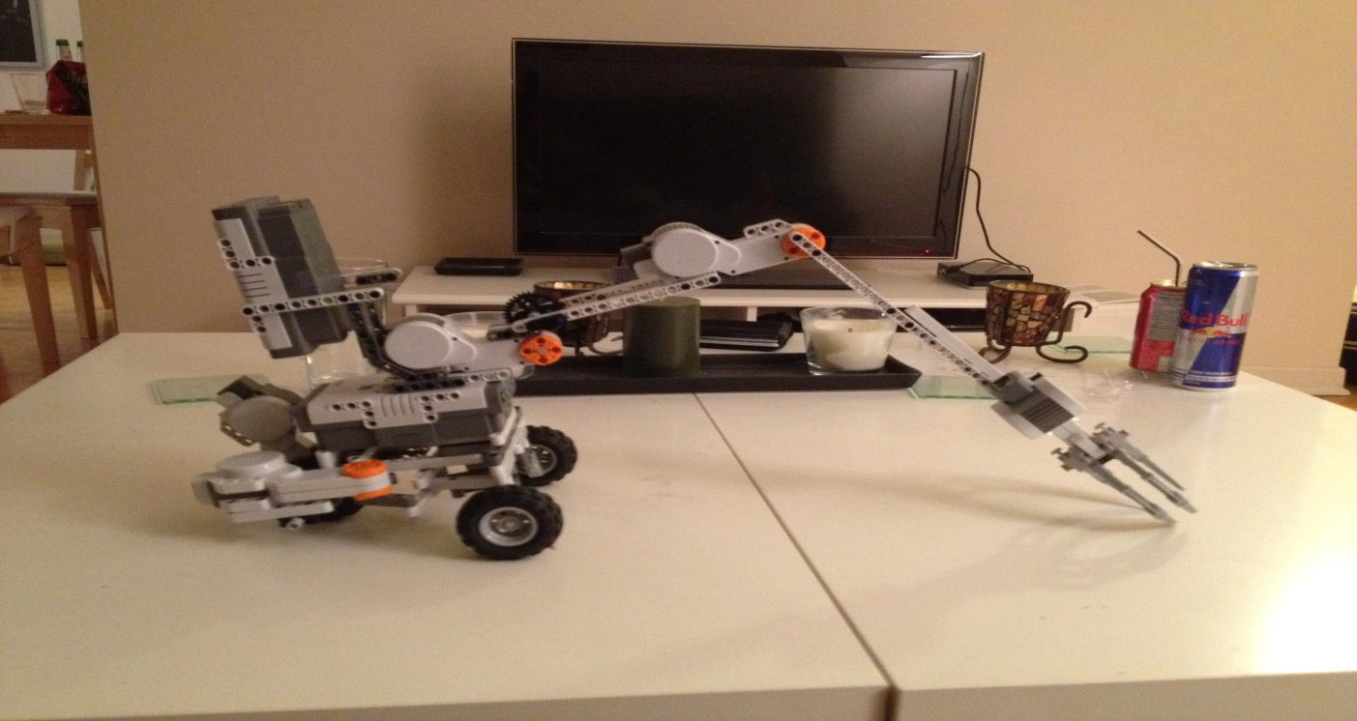

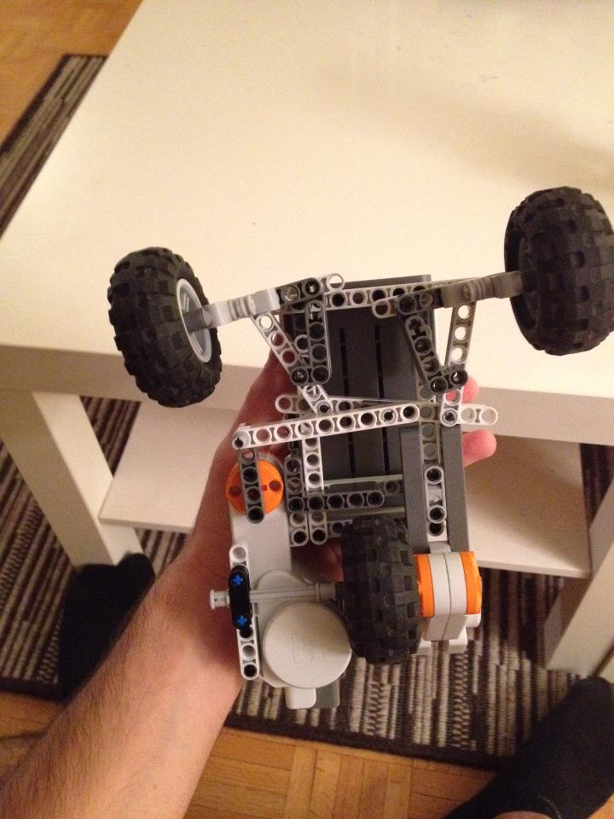

Number of Bricks and Inter-Brick Communications Protocol:

The software development and the mechanical design team, after some deliberations, have agreed upon the principle of using two NXT Bricks. This is mainly due to the need to manage different functions simultaneously. The functions of the robot will be divided between the two bricks, with one brick involved in managing the motors handling the mechanical arm and the other brick being used to operate the motors involved in running the wheels. Both teams decided on the division of sensor functions between the two bricks to simplify matters. In addition, the two bricks will be placed side by side to allow easy handling in case of design adjustments or battery replacement. With regards to the inter brick communications protocol, it was established that a wire would be used in place of a Bluetooth as it simplifies matters. We also did not wish to interfere with the given Bluetooth class.